# STRAT_FORM = YEAR vs SURVEYID (er_est=R2)

## winter

## 

## Spring

## 

## Summer

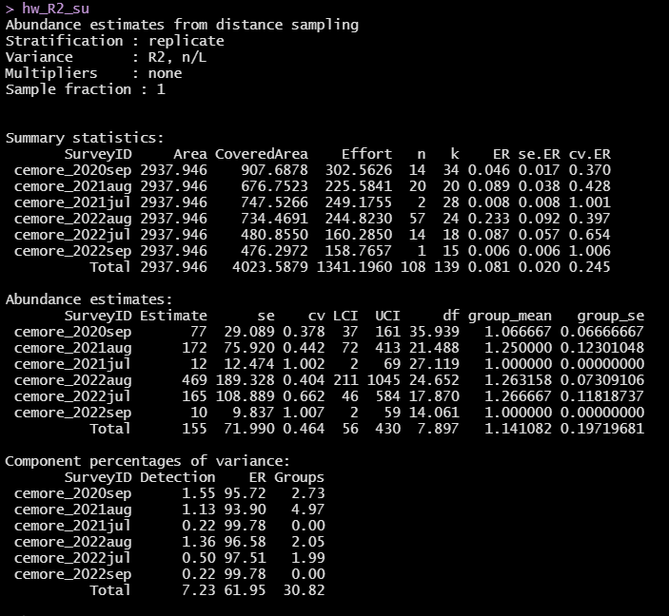 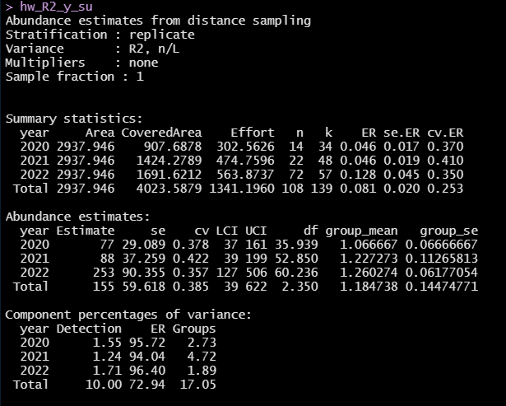

## Fall

## 

# Compare

## Winter: R2 vs. O2

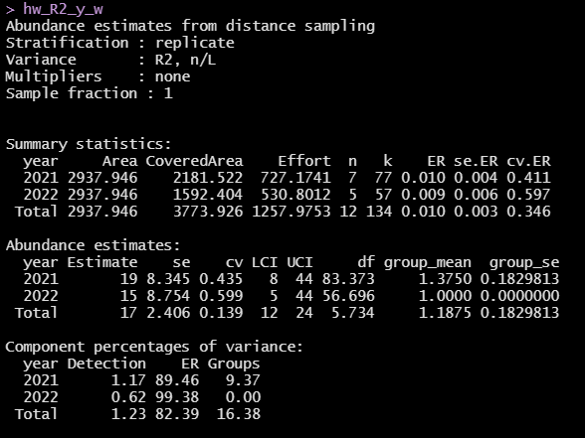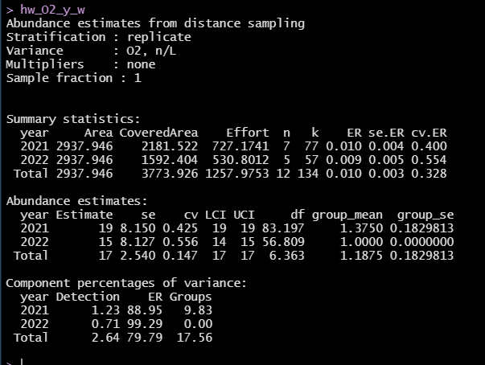

## Spring: R2 vs. O2

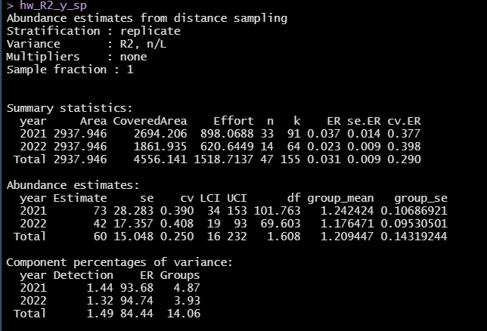

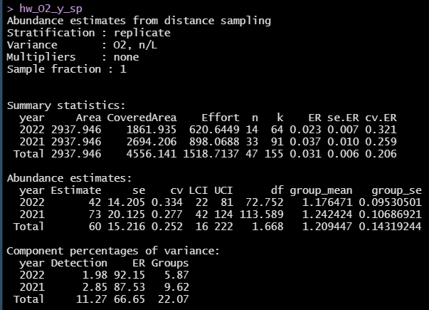

## Spring: R2 vs. O2



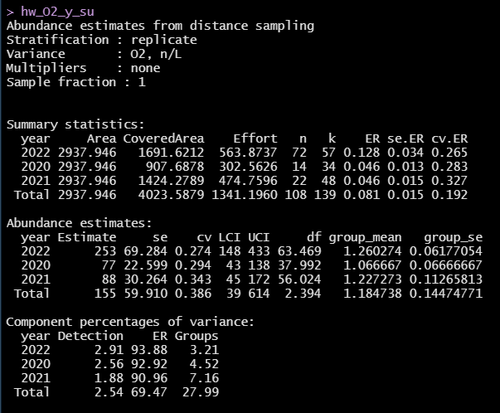

## Fall: R2 vs. O2

